Operational Concept Description (OCD)

Mission Science Information and Data Management System

Team 06

Team member | Roles
Celia Kung | Project Manager | Planning and Control Engineer
Hardik Shah | Feasibility Analyst | Requirements Engineer
Brian Anderson | Operational Concept Engineer | Project Manager
Yujie Chen | Prototyper | System Architect
Zhenlu Sun | Requirements Engineer | Operational Concept Engineer
Kathleen Barrera | Quality Focal Point | System Requirement Engineer
Wei Tan | System Architect | Prototyper

11/21/2011

Version History
Date | Author | Version | Changes made | Rationale
09/23/11 | Zhenlu Sun&Yujie Chen | 1.0 | - Initial version of OCD | - Using with Operational Concept Description (OCD) for NDI/ NCS template Version 1.0
10/10/11 | Brian Anderson | 1.1 | - Updated the team roles table on cover page  - The Benefits Chain Analysis  - Expanded the OCD status section (section 1.2)  - Updated section 2.3 Expected Benefits | - The Benefits Chain Analysis has changed after our winwin negotiations meeting.  - The benefits were more accurately defined after the winwin meetings and the resulted in the need to update the corresponding sections.
10/14/11 | Brian Anderson | 1.2 | - Updated section 2.5 System and Boundary  - Updated section 3.2.1 Capability Goals  - Updated section 3.3.1 Element Relationship Diagram  - Updated the Benefits Chain Analysis | - Diagram was wrong (Student Workers were on the wrong side)  - OC-3 needed clarification  - Diagram was missing  - Benefits Chain Analysis was misrepresenting the system
10/22/11 | Brian Anderson | 1.3 | - Updated section 3.3.1 Element Relationship Diagram  - Updated the Benefits Chain Analysis | - Diagram was not accurate  - Benefits Chain Analysis was misrepresenting the system
11/21/11 | Kathleen Barrera | 1.4 | - Updated Benefits Chain Analysis (Figure 1)  - Update workflow (3.1 Current Business Workflow)  - Update workflow (3.3.2 New Operational Concept Business Work flow)  - Updated entity diagram (3.1.3) | - Apply changes from DCP review and meeting with TA on benefits chain analysis  - Update terminology to stay consistent with SSAD
11/27/11 | Kathleen Barrera | 1.5 | - Updated Benefits Chain Analysis (Figure 1) | - Formatting had errors
12/5/11 | Kathleen Barrera | 1.6 | - Updated entity diagram (3.1.3) | - Added users to the outside of the entity diagram

Table of Contents
Operational Concept Description (OCD) i
Version History ii
Table of Contents iii
Table of Tables iv
Table of Figures v
1. Introduction 1
1.1 Purpose of the OCD 1
1.2 Status of the OCD 1
2. Shared Vision 2
2.1 Success-Critical Stakeholders 2
2.2 System Capability Description 2
2.3 Expected Benefits 3
2.4 Benefits Chain 4
2.5 System Boundary and Environment 5
3. System Transformation 6
3.1 Information on Current System 6
3.2 System Objectives, Constraints and Priorities 8
3.3 Proposed New Operational Concept 10
3.4 Organizational and Operational Implications 13

Table of Tables
Table 1: Success-Critical Stakeholders 2
Table 2: Capability Goals 8
Table 3: Relation to Current System 9

Table of Figures
Figure 1 Benefit Chain 4
Figure 2: System Boundary and Environment Diagram 5
Figure 3: Current Business Workflow for Inventory Control 7
Figure 4: Business Workflow Diagram for student participation in program 8
Figure 5: Entity Relationship Diagram 11
Figure 6: Proposed Inventory Business Workflow 12
Figure 7: Business Workflow Diagram of Information and Database System 13

Introduction

Purpose of the OCD
To describe the success-critical stakeholders' shared vision of the project being undertaken. The requirements are still being gathered and the design of the proposed system is being developed.
This document provides, in detail, the shared visions and goals of the stakeholders of the Information and Database Management System for the Mission Science. The success-critical stakeholders of the project are Darin Gray, as the project owner; the Mission Science student workers and Darin Gray, as users; Darin Gray, as the maintainer.

Status of the OCD
The status of the OCD has been reviewed by all team members and class staff. This document has been changed to include the agreed upon benefits following the two winwin negotiation meetings. The updates in the benefits were the basis for a new benefits chain analysis to be accomplished. Brian Anderson has been assigned as the primary Operational Concept Engineer.

Shared Vision
The system needs to be a more robust integrated database that stores and tracks Students demographics, Inventory and Costs, Lesson plans, and Applicable Standards .

Success-Critical Stakeholders
Table 1: Success-Critical Stakeholders
Stakeholder | Authorized Representatives | Organization | Relation to Benefits Chain
Client | Darin Gray | Mission Science | - Provide information and feedback to the development team.  - Use the system.  - Provide training to the future user.
Development Team | Celia Kung  Brian Anderson  Hardik Shah  Yujie Chen  Zhenlu Sun | Csci577a, team06 of University of Southern California | - Understand requirements of required system.  - Import data into new systems databases.  - Design new system architecture.  - Document and train client on new system.
IIV&Ver | Kathleen Barrera | Csci577a, team06 of University of Southern California | - Identify the detects of system to facilitate corrective action

System Capability Description
- The type of system to be built
Using existing NDI (Microsoft Access as proposed) to get accesses to the Database storing information of inventory, student, project and so forth.
- The target customer(s) for the system
Mission Science student workers and Darin Gray
- The need or opportunity that will be satisfied by the system
  - The new system will have integrated databases that will result in consistent and accurate data.
  - The new system will conform to all appropriate national and state standards.
  - Teachers will be able to plan their science class and an accurate inventory will be available for the teacher to determine if they can accomplish the project or not.
  - The new system will allow client to maintain inventory with respect to each project to instantly know if he has enough materials to implement each project.
  - Allow teachers to do planning for their science classes. They will have access to projects, themes, and materials.
  - Currently there is no system in the industry that can accomplish all of the user’s needs. The user will save time and will have a more robust system once all needs have been satisfied.

Expected Benefits
  - University want to serve as the model for other urban university to find students interested in STEM careers from untapped resources of inner city.
  - Once number of students is increased, it’s in the country’s best interest to have more people in technical careers.
  - Increase the number of underrepresented students in STEM careers.
  - Cost benefit analysis will help with present university’s massive fundraising.
  - Funded by National Research for the last 11 years, but funding is not guaranteed year to year.. Want to see longitudinal data.
  - Allow client to maintain inventory with respect to each project to instantly know if he has enough materials to implement each project.
  - Allow teachers to do planning for their science classes. They will have access to projects, themes, and materials.
  - Allow all the projects to be aligned to National and California State standards.
  - For research purposes, we want to be able to do a longitudinal study of the students that are in the program and the projects they have finished and how that realizes to science technology.

Benefits Chain
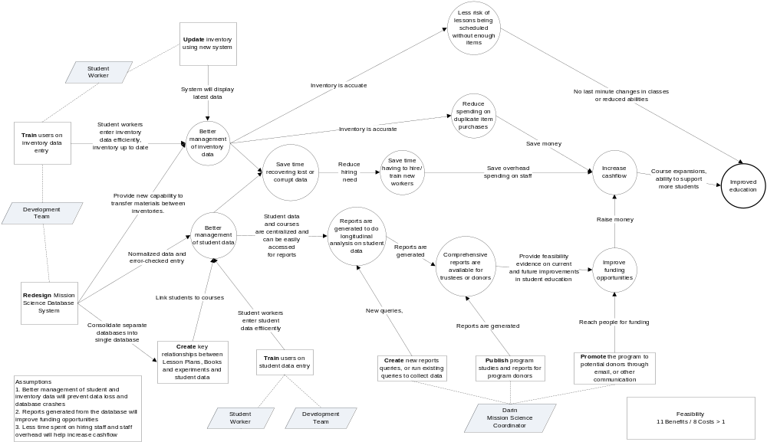

Figure 1 Benefit Chain

System Boundary and Environment

Administrator
Inventory Management System
Books and Experiments Management System
Mission Science Sign In Input Management System
Precollege Lesson Plan Management System

Student workers

MS Access
Windows 7

Figure 2: System Boundary and Environment Diagram

System Transformation

Information on Current System

Infrastructure
Microsoft Access dashboard
Access Database
Flash drive/ USB disk
PC with Windows 7 operation system

Artifacts
Artifact | Purpose
ATF1-Lesson Standards | Including National and State Standards, depend on what stuff will determine whether student application will be approved or not
ATF2-Tools and Material | Contains its location price amount, so that lesson plan can make use of it
ATF3- Project Form | Teacher will create a lesson plan by submit Lesson plan form which includes keywords description , standards and so forth
ATF4- Inventory | Essentially maintain the amount of each items in each location, so that all user of the system will know if items is still enough for lesson and experiment go on
ATF5- SignIn Sheet | Will determine whether a student will meet the standards and can be accepted by certain project
ATF6- Student Profile | Including student demographic information
ATF7- Report | Admin will run query upon the integrated database, and perform longitudinal study.

Current Business Workflow
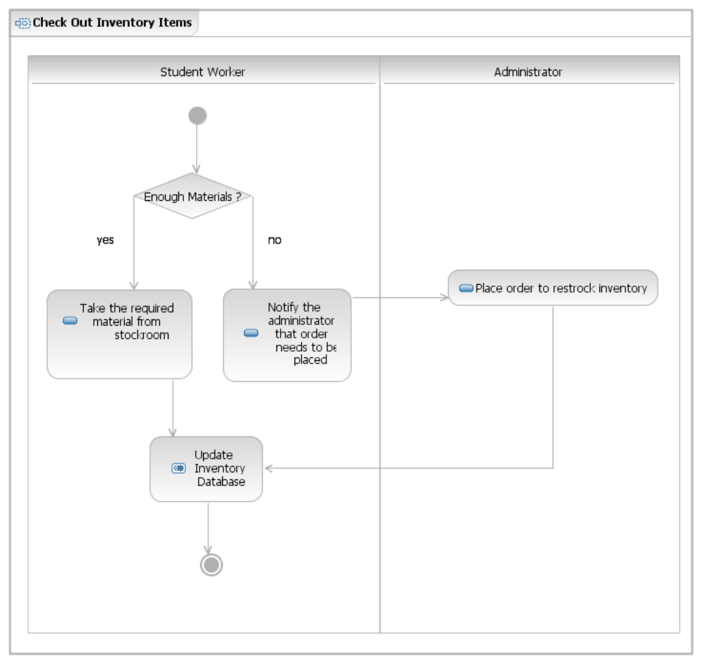
Figure 3: Current Business Workflow for Inventory Control

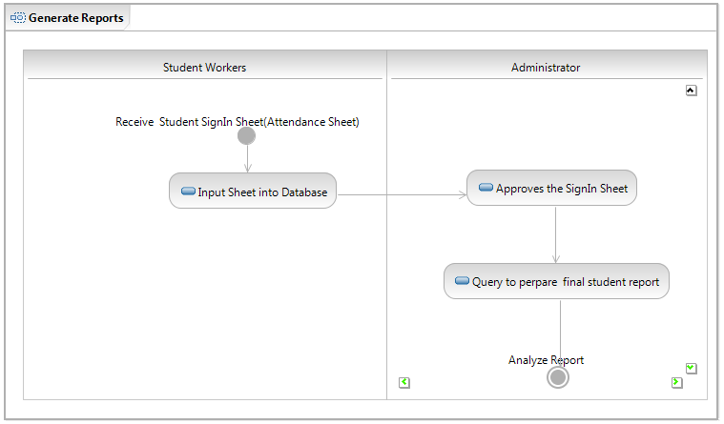
Figure 4: Business Workflow Diagram for student participation in program

System Objectives, Constraints and Priorities

Capability Goals
Table 2: Capability Goals
Capability Goals | Priority Level
OC-1 Student Information Management: Student information regarding lessons they have completed, demographic information, and years participated in the Mission Science program to be accessible from a centralized system by administrator. | Must have
OC-2 Inventory Management: Detailed information including pictures, quantity, price by vendor, and location to be accessible from centralized system by student workers and administrator. | Must have
OC-3 User Interface: Students workers and Administrators can access database through new MsAccess login form interface. | Should have
OC- 4 Back-up Management: All databases, to include tables, queries, and database relationships will be backed-up at predetermined intervals. | Could have
OC-5 Project Management: Can add new lesson as they are created. This includes procedures, resource management, compliance to standards, and links to how-to videos for a given project. | Must have
OC-6 Role Based Access: Supply the capability that depending on who logs in their capabilities are restricted to only those applicable to their function. | Must have

Level of Service Goals
This section is not applicable – The client did not specify any level of service requirements.

Organizational Goals

OG-: Improve higher quality of “mission science education”
OG-2: Help education organization keep track of students’ interest in science
OG-3: University want to serve as the model for other urban university to find students interested in STEM careers from untapped resources of inner city.
OG-4: Inspire more people to pursue technical careers to benefit the country to keep up with world trends.
OG-5: Increase the number of underrepresented students in STEM careers.

Constraints

CO-1: Windows as an Operating System: The new system must be able to run on Windows platform.
CO-2: Zero Monetary Budget: The selected NDI/NCS should be free or no monetary cost.

Relation to Current System
Table 3: Relation to Current System
Capabilities | Current System | New System
Roles and Responsibilities | - Students workers and Administrator have to perform tedious and repetitive tasks | - Some results can be generated automatically
User Interactions | - There exist some errors of results administrator gets  - Update of data always results in inconsistency  - Some functions cannot work well  - Redundant data entry | - Minimum redundancy  - Data consistency in the whole database  - Point-of-entry validation
Infrastructure | - Separated five Databases | - Integrated one Database
Stakeholder Essentials and Amenities |  | - Save money in buying inventories  - Improve education qualities
Future Capabilities |  | - Web interface

Proposed New Operational Concept

Element Relationship Diagram

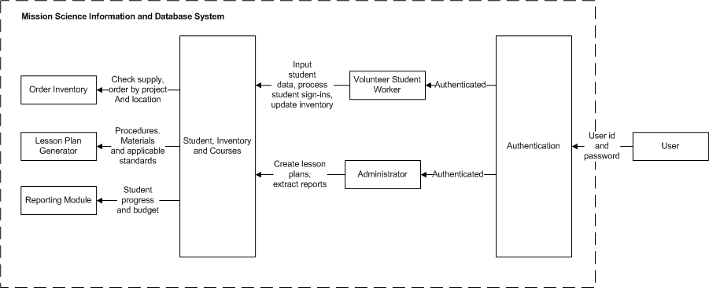
Figure 5: Entity Relationship Diagram

Business Workflows
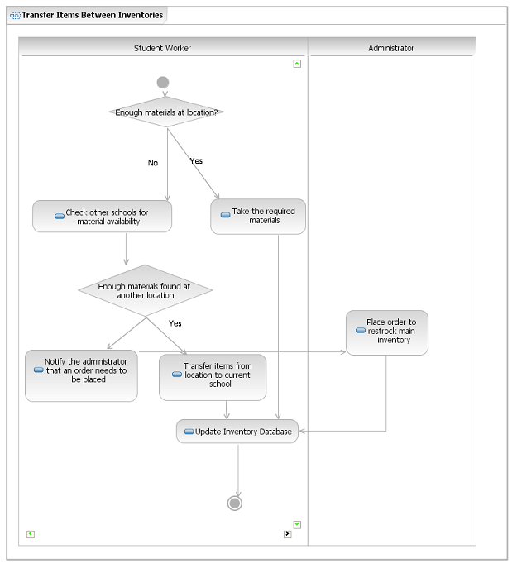
Figure 6: Proposed Business Workflow for Inventory Control
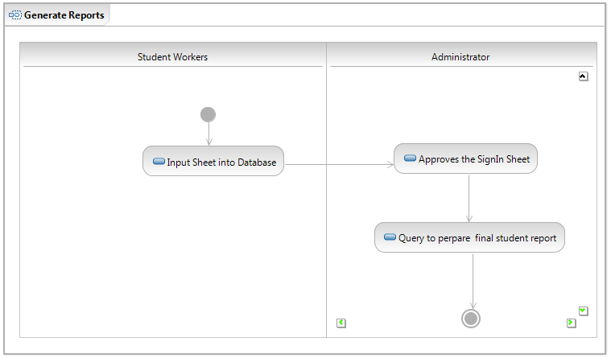
Figure 7: Business Workflow Diagram of Information and Database System

Organizational and Operational Implications

Organizational Transformations
- Administrator will be the only one with privileges to create/modify lesson plans
- Administrator will be the only one with privileges to run/create queries and reports (including but not limited to student summary, student progress, and program cost)

Operational Transformations
- System users can only access database through login interface
- Creating and modifying lesson plans will only be done by the administrator
- Integrate five databases into one database
- Change or delete illogical schemas

